**BANKING SYSTEM REQUIREMENTS DOCUMENTATION**

**Functional Requirements**

**1. Customer Management**

* New customers can register by entering personal details (name, address, contact info).
* Customers can log in securely with their username and password.
* Customers can edit or update their personal details.
* Employment details are stored for cheque account applications.

**2. Account Management**

* Customers can open different types of accounts: Savings, Investment, or Cheque.
* Each account will have its own unique account number.
* Special rules apply when opening accounts:
  + Investment Account: Needs at least BWP500.00 to start.
  + Cheque Account: Requires proof of employment.
* Customers can see all their accounts and current balances.

**3. Transaction Processing**

* Money can be deposited into any account.
* Withdrawals can be made from Investment and Cheque accounts only.
* Withdrawals are not allowed from Savings accounts.
* The system keeps a record of all transactions.
* Withdrawals only go through if there’s enough money in the account.

**4. Interest Calculation**

* Interest is added every month:
  + Savings Account: 0.05% per month.
  + Investment Account: 5% per month.
* Interest is credited to accounts automatically.

**5. Reporting**

* Customers can get account statements.
* Transaction history reports are available.
* Current balances are always displayed.

**Non-Functional Requirements**

**1. Security**

* All customer data and passwords must be encrypted.
* The system must use secure login methods.
* Every transaction should have an audit trail (record).
* Access should be based on user roles (e.g., customer, admin).
* The system must block unauthorized access attempts.

**2. Performance**

* Transactions should be processed within 3 seconds.
* The system must allow many users to use it at the same time.
* Balance checks should load in under 2 seconds.
* The system should handle high usage during busy business hours.

**3. Usability**

* The system should have an easy-to-use graphical interface.
* Error messages and feedback should be clear and easy to understand.
* Users with basic computer skills should be able to use the system.
* Help guides and user instructions should be available.

**4. Reliability**

* The system should be available 99.9% of the time during business hours.
* Automatic data backups must be done regularly.
* The system should allow data recovery if something goes wrong.
* Data must stay accurate and consistent across all operations.

**5. Maintainability**

* The system should be built with modular, object-oriented design.
* Full documentation must be provided.
* Configuration changes should be simple to make.
* Logging must be in place to help with debugging issues.

**STRUCTURAL UML MODELLING**

USE CASE DIAGRAM

CLASS DIAGRAM

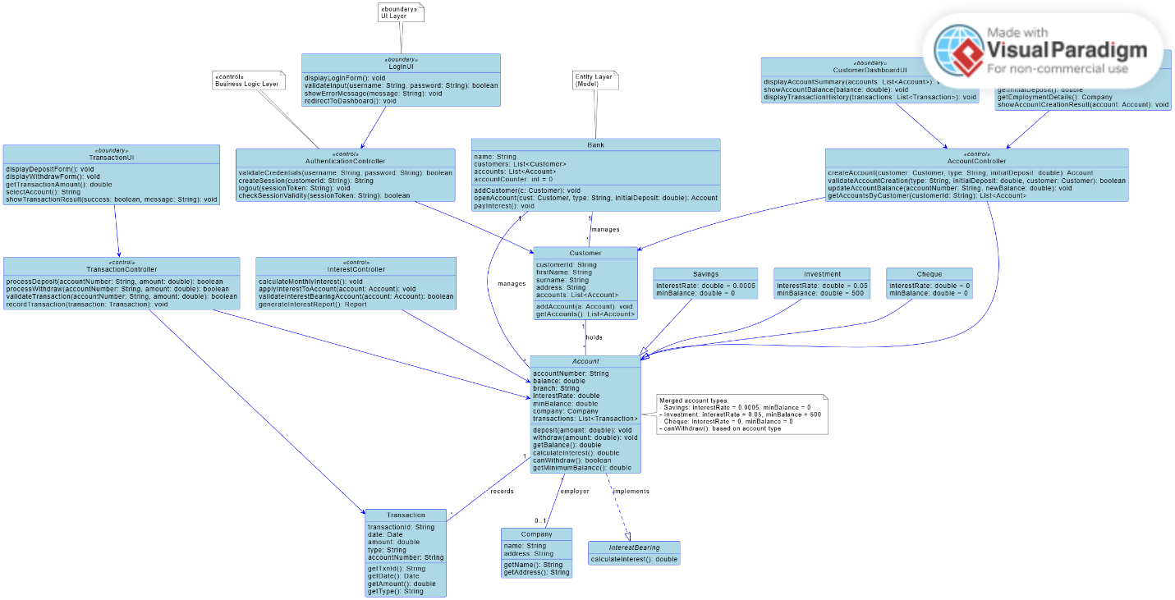

**BEHAVIOURAL UML MODELLING**

SEQUENCE DIAGRAM

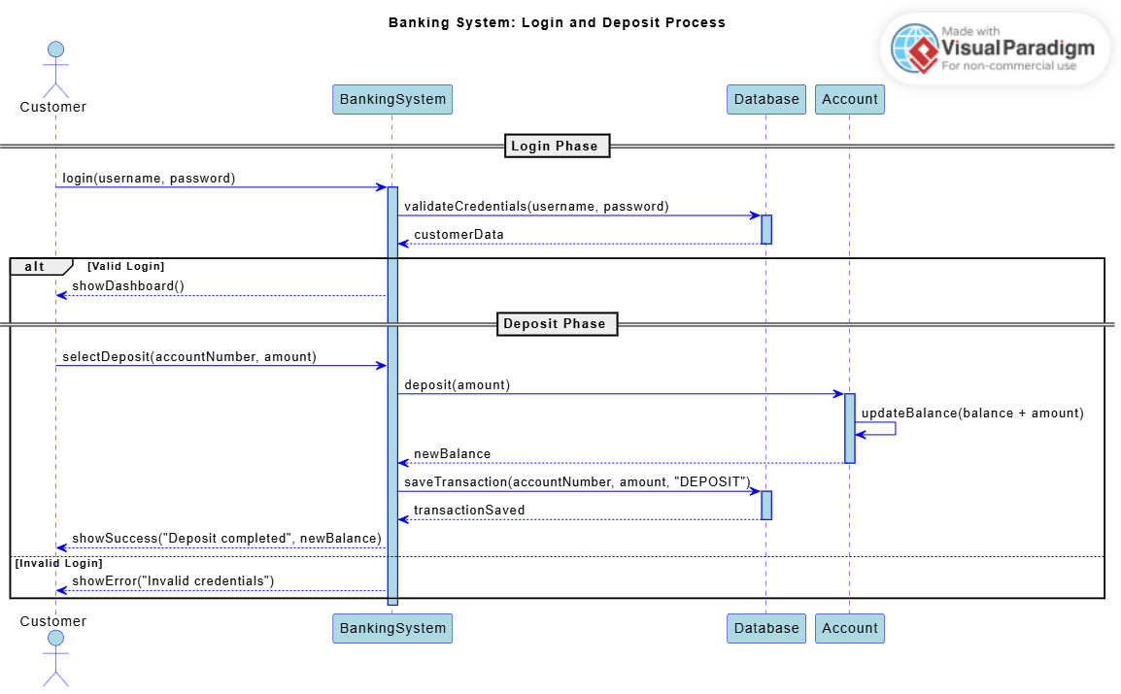

STATE DIAGRAM

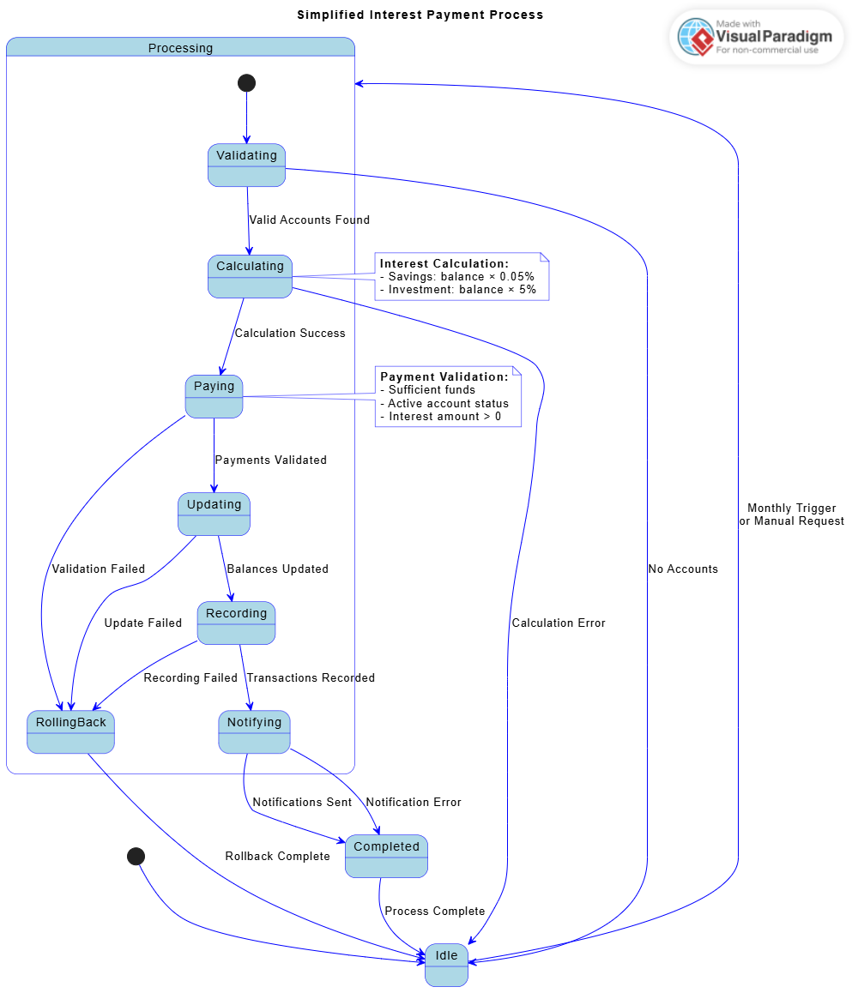

**Appendix – Interview Record**

**Interview Details**

* **Date:** [18 Septermber 2025]
* **Interviewer:** [Moathodi Ditshike]
* **Interviewee:** [Themba Moeng]
* **Duration:** 30 minutes
* **Purpose:** To gather requirements for the Banking System

**Key Questions and Answers**

**Q1: What main functions should the banking system have?**

* It should allow customer registration, support different account types, handle secure transactions, and calculate interest automatically.

**Q2: What account types should be included?**

* Savings (deposit only, low interest), Investment (higher interest, requires minimum deposit), and Cheque (for salary deposits, requires proof of employment).

**Q3: What security features are most important?**

* Strong login authentication, encrypted data, transaction records (audit trails), and blocking unauthorized access.

**Q4: What are your performance expectations?**

* Transactions should be processed in under 3 seconds, the system should be available most of the time, and support multiple users at once.

**Q5: How should interest be handled?**

* Interest should be added automatically every month: 0.05% for Savings and 5% for Investment accounts.

**Q6: What reports should the system provide?**

* Account statements, transaction history, balance checks, and management reports for the bank.

**Q7: How do we check if someone is really employed for a cheque account?**

* For now, just let them type in their work info. A bank manager will have to approve the account in the system before it can be used.

**Q8 : How should the system handle customer authentication and login?**

* The system will use a username and password for login, where passwords are stored securely as hashes, and upon logging in, the system will remember the user and give them access only to their own accounts.

**Q9: Should there be any maintenance fees for the accounts?**

* No, not for this initial system. The current requirements focus on core functionality: deposits, withdrawals, and interest payments.